**Question 1**(15 points)

*Saved*

[**ListenReadSpeaker webReader: Listen**](https://app.readspeaker.com/cgi-bin/rsent?customerid=10078&url=https%3A%2F%2Flearn.sait.ca%2Fd2l%2Flms%2Fquizzing%2Fuser%2Fattempt%2Fquiz_attempt_page_auto.d2l&lang=en_us&voice=10078&readid=d2l_read_element_1)Focus

Given the following physical model for websites accessed by employees of XYZ Enterprises create an equivalent Oracle Database.

Drop any existing tables at the start of your script.

For  the xyz_Website, xyz_EmployeeWebsites and xyz_Employee tables,  add ALL constraints within the CREATE TABLE statements (using column or table level constraints).

For the xyz_Access table add ALL the constraints AFTER the CREATE TABLE statement through the use of ALTER TABLE. Appropriately name all constraints.

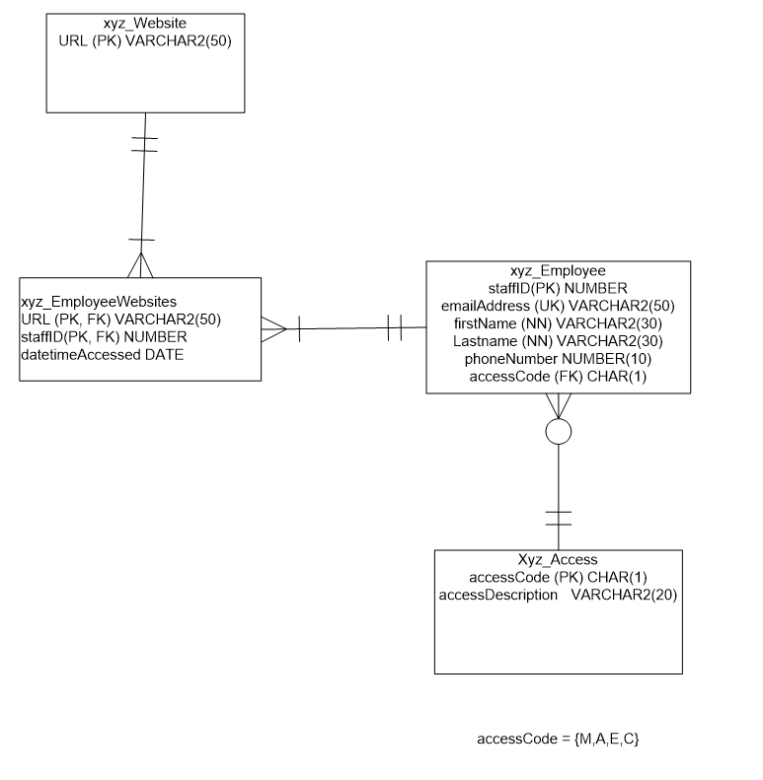

Question 1 options:

|  |
| --- |
|  |
| |  |  | | --- | --- | | Add a FileRecord AudioRecord Video |  | |

**Question 2**(2 points)

[**ListenReadSpeaker webReader: Listen**](https://app.readspeaker.com/cgi-bin/rsent?customerid=10078&url=https%3A%2F%2Flearn.sait.ca%2Fd2l%2Flms%2Fquizzing%2Fuser%2Fattempt%2Fquiz_attempt_page_auto.d2l&lang=en_us&voice=10078&readid=d2l_read_element_2)

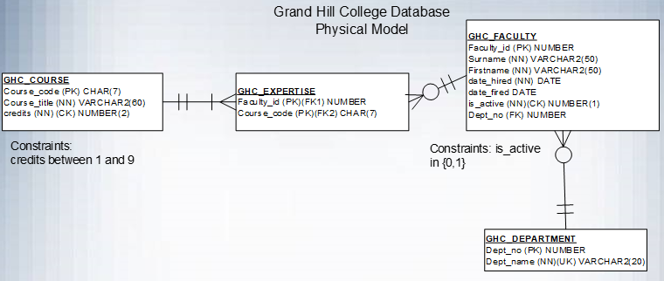

Add the following department and faculty information

* Astronomy Department, Dept Number 101

Here are the Faculty in the Astronomy Department:

* Faculty ID: 37422,John Brorsen, Hired: Mar 1, 2002, Active
* Faculty ID: 388231, William Bradfield, Hired: July 1, 2010, Active

Attach the script.

Question 2 options:

|  |
| --- |
|  |
| |  |  | | --- | --- | | Add a FileRecord AudioRecord Video |  | |

**Question 3**(2 points)

[**ListenReadSpeaker webReader: Listen**](https://app.readspeaker.com/cgi-bin/rsent?customerid=10078&url=https%3A%2F%2Flearn.sait.ca%2Fd2l%2Flms%2Fquizzing%2Fuser%2Fattempt%2Fquiz_attempt_page_auto.d2l&lang=en_us&voice=10078&readid=d2l_read_element_3)



Change all the 200 level courses (there is a '2' at position 5) to be 4 credits.

Paste in the resultant script with results into the textbox shown.

Question 3 options:

UPDATE GHC_COURSE

SET CREDITS = 4

WHERE COURSE_CODE IN

(SELECT COURSE_CODE

FROM GHC_COURSE

WHERE COURSE_CODE LIKE '____2__'

);

|  |
| --- |
|  |

**Question 4**(2 points)

[**ListenReadSpeaker webReader: Listen**](https://app.readspeaker.com/cgi-bin/rsent?customerid=10078&url=https%3A%2F%2Flearn.sait.ca%2Fd2l%2Flms%2Fquizzing%2Fuser%2Fattempt%2Fquiz_attempt_page_auto.d2l&lang=en_us&voice=10078&readid=d2l_read_element_4)



William Bradfield has been fired and is no longer active. Update the database to reflect this change. Fire date is May 1, 2021. Active is represented by 1 and fired is represented with a 0.  
Note: You may or may not have an faculty member named William Bradfield but write the command as if you did. Don't worry if Oracle says that there are no rows selected when it is executed.

Paste the script into the textbox.

Question 4 options:

|  |
| --- |
|  |
| |  |  | | --- | --- | | Add a FileRecord AudioRecord Video |  | |